WCF Basic :
CREATE A SERVICE:
Step 1: Create a Class Library Project ClassLibrary1
Step 2:Add a System.Servicemodel
[ServiceContract]
interface Iservice1
{
[OperationContract]
string hello(string x);
}

Step 3: add a service class
public class Service1: Iservice1
{

}

Step 4: Implementation part
public class Service1 : Iservice1
{

public string hello(string x)
{
return (x + "hello");
}
}

Step 5: BUILD this
Step 6: Add another Project “Console application” in the same solution “HOST”

using System.ServiceModel;
using ClassLibrary1;

Step 7: Add the logic in main method
class Program
{
static void Main(string[] args)
{
ServiceHost h = new ServiceHost(typeof(ClassLibrary1.Service1));

h.Open();
Console.WriteLine("am alive");
Console.ReadKey();

h.Close();
}
}

Step 8: add a App Config file into your host project. And BUILD

Step 9: get a config file editor exe. (open with on app config)
C:\Program Files (x86)\Microsoft SDKs\Windows\v7.0A\Bin\NETFX 4.0 Tools\SvcConfigEditor.exe"
Step 10:
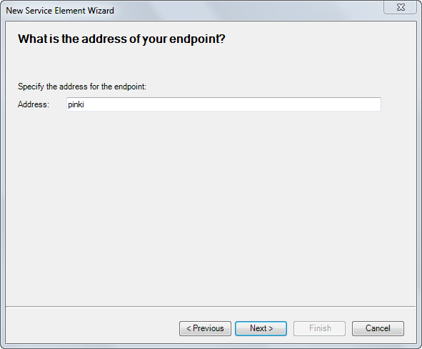

Step 11:

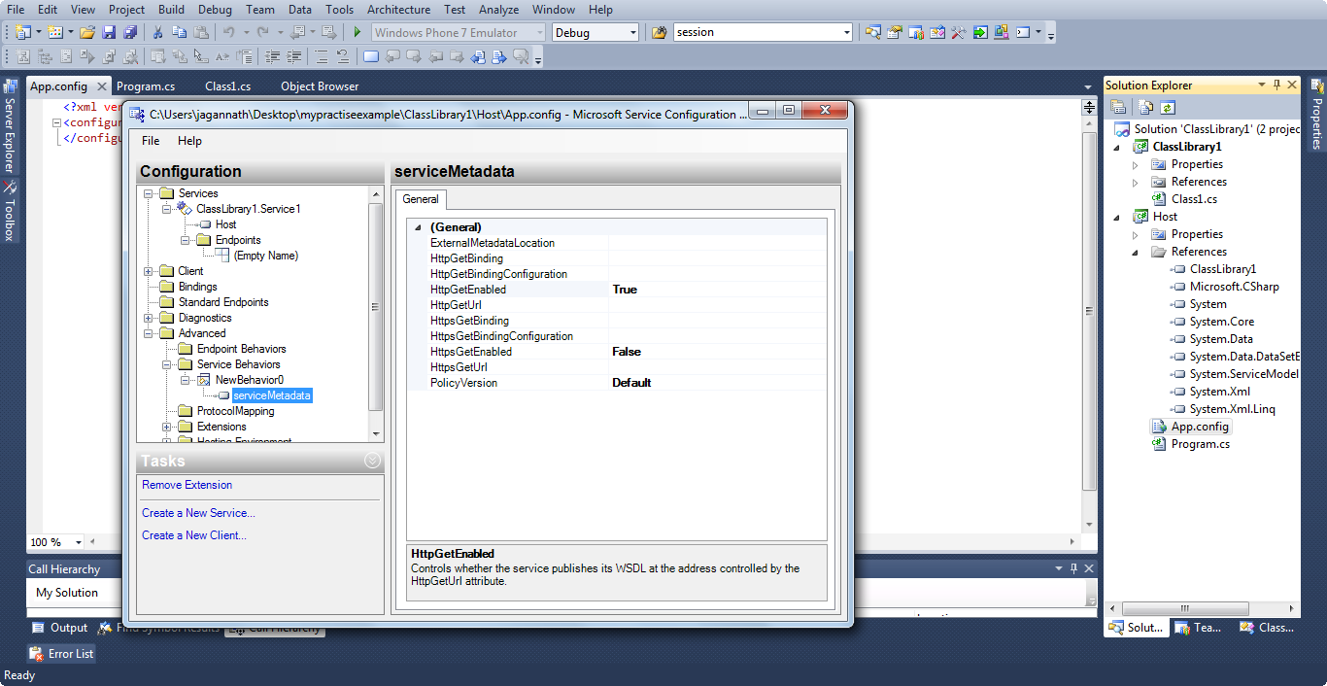
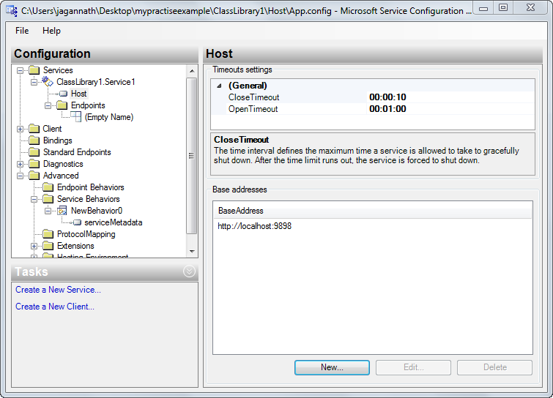

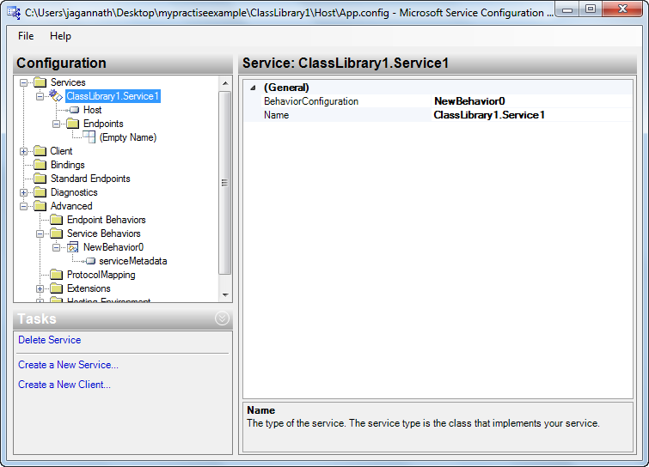

<?xml version="1.0" encoding="utf-8" ?>
<configuration>
<system.serviceModel>
<behaviors>
<serviceBehaviors>
<behavior name="NewBehavior0">
<serviceMetadata httpGetEnabled="true" />
</behavior>
</serviceBehaviors>
</behaviors>
<services>
<service behaviorConfiguration="NewBehavior0" name="ClassLibrary1.Service1">
<endpoint address="pinki" binding="basicHttpBinding" bindingConfiguration=""
contract="ClassLibrary1.Iservice1" />
<host>
<baseAddresses>
<add baseAddress="http://localhost:9898" />
</baseAddresses>
</host>
</service>
</services>
</system.serviceModel>
</configuration>

CRETAE A CLIENT

Step 1: create another console app. “clientforwcfbasic”
static void Main(string[] args)
{

ServiceReference1.Iservice1Client p = new ServiceReference1.Iservice1Client();

string x = p.hello("krunal ");
Console.WriteLine(x);
Console.ReadKey();
}

